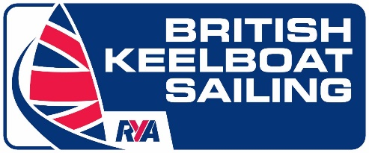

Marlow Ropes Women’s Match Racing Championships
WPNSA
11/12th September 2021

PROGRAMME

Friday
16.00 – 18.00 Training Team H
Teams can register and weigh in with Jack Fenwick.

Saturday
08.00 – 08.40 Registration and weighing, WPNSA Dock/under balcony. (see allocated times)
09.00 Virtual First briefing/skippers briefing, meet with the umpires, Boat Draw & Collect bibs.
Rig the boats/Practice sailing
09.30 Racing (Intended first signal 09.23)
Finish racing, come off the water and pack up boats
Debrief (on dock/under balcony, when ashore)
18.00 Pimms at RYA Portland House.

Sunday
08.00 Virtual morning briefing, meet with the Umpires, WPNSA Dock/under balcony.
Rig the boats.
09.00 Racing (Intended first signal 08.53)
Finish racing, come off the water and pack up boats, give bibs back & Prize Giving on the dock/under balcony (weather permitting).

